**U.S. Smartphone Use in 2015**

<http://www.pewinternet.org/2015/04/01/us-smartphone-use-in-2015/>

10% of [Americans own a smartphone but *do not have any other form of high-speed internet access at home* beyond their phone’s data plan.](https://twitter.com/intent/tweet?url=http://pewrsr.ch/1NF3kbK&text=10%25%20of%20Americans%20have%20no%20broadband%20service%20at%20home%20other%20than%20their%20smartphone%20data%20plan.)

* 15% of Americans own a smartphone but say that they have a *limited number of ways to get online other than their cell phone*.

Young adults (85% of whom are smartphone owners)

* 68% [of smartphone owners use their phone at least occasionally to *follow along with breaking news events*, with 33% saying that they do this “frequently.”](https://twitter.com/intent/tweet?url=http://pewrsr.ch/1NF3kbK&text=68%25%20of%20smartphone%20owners%20use%20their%20phone%20to%20follow%20breaking%20news%3B%2033%25%20do%20so%20frequently.)
* 67% use their phone to *share pictures, videos, or commentary about events happening in their community*, with 35% doing so frequently.

56% use their phone at least occasionally to *learn about community events or activities*, with 18% doing this “frequently.”

Four-in-ten smartphone owners ages 65 and older use their phone at least occasionally to keep up with breaking news, half use it to share information about local happenings, and one-third use it to stay abreast of events and activities in

Three smartphone features in particular — social networking, watching video, and listening to music or podcasts — are especially popular with younger users. Fully 91% of smartphone owners ages 18-29 used social networking on their phone at least once over the course of the study period, compared with 55% of those 50 and older (a 36-point difference). These young smartphone owners reported using social networking in an average of 5.6 surveys, tied with internet use as the second-most frequent smartphone behavior among young adults after text messaging.their community.

Ownership levels remain particularly low among seniors, as just 27% of Americans 65 and older now own a smartphone. However, this does represent an 8-point increase in ownership among seniors compared with early 2014.

23% of smartphone owners have had to cancel or suspend their service in the past due to financial constraints -- These financial challenges are especially common among lower-income smartphone owners, as fully 44% of smartphone owners with an annual household income of less than $30,000 have had to let their service lapse at some point or another.

Along with lower-income users, African Americans and Latinos are around twice as likely as whites to have canceled or cut off their smartphone service, and younger smartphone owners are substantially more likely to have done so compared with older adults.

Similarly, 43% of black smartphone owners, 49% of Latinos, and 48% of those ages 18-29 say that they reach the maximum amount of data they are allowed to use on their plan at least occasionally, with around one-in-five from each group indicating that this happens to them frequently.

Fully 15% of Americans ages 18-29 are heavily dependent on a smartphone for online access (20% of have a smartphone but not traditional broadband service, and 25% have a smartphone but have relatively limited options for going online otherwise).

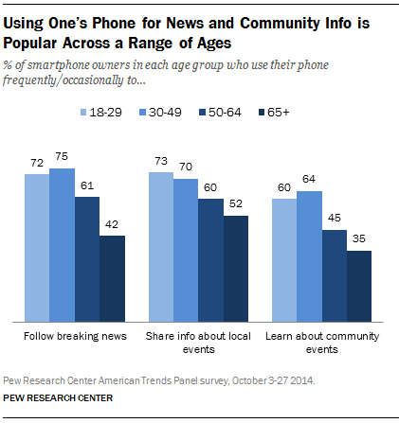

Smartphone owners are nearly evenly divided on this question; 54% say that their phone is “not always needed,” while 46% say that it is something they “couldn’t live without.” Women and African Americans have higher than average levels of attachment: half of female smartphone owners (52%) say that their phone is something that they couldn’t live without (compared with 39% of men), as do 57% of African American smartphone owners (compared with 46% of whites).

A substantial majority of smartphone owners (80%) describe their phone as “worth the cost,” although one-in-five (19%) describe it as a “financial burden.”

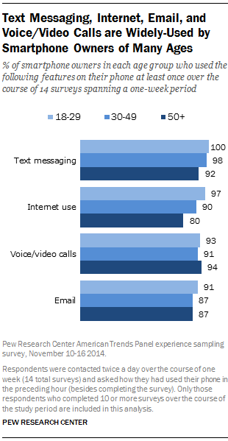

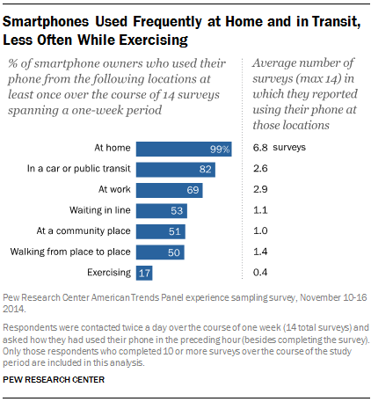

Home usage is ubiquitous among smartphone owners both young and old, and smartphone owners ages 18-29 and those 50 and older are similarly prone to using their phones while in a car or on public transit (85% of younger users and 79% of older users did so), as well as in a community place like a park or coffee shop (49% of both younger and older smartphone owners used their phone in this type of location over the course of the study period).

However, younger adults are substantially more likely to use their smartphone while walking from place to place. Almost two-thirds of 18-29 year olds (64%) did this at least once during the week-long study period, compared with 48% of smartphone owners ages 30-49 and 37% of those 65 and older. Smartphone owners ages 18-29 are also a bit more likely than those 50 and older to use their phone while waiting in line (55% vs. 43%) and while exercising (21% vs. 11%).

<http://www.pewresearch.org/fact-tank/2015/04/01/6-facts-about-americans-and-their-smartphones/>

Today, nearly two-thirds (64%) of U.S. adults own a smartphone, up from 35% in 2011. Younger adults as well as those who are more affluent and have higher levels of education are among the most likely groups to own a smartphone.

Some smartphone owners – particularly younger adults, minorities and lower-income Americans – depend on their smartphone for internet access. Of U.S. adults who own a smartphone, 7% are “smartphone-dependent,” meaning that they do not have home broadband service and have limited options for going online other than their mobile device. Young adults, ages 18-29, are more likely (15%) than other age groups to be smartphone-dependent, while Latinos (13%) and African Americans (12%) are more heavily dependent on their smartphone for internet access than are whites (4%). Lower-income Americans also rely heavily on smartphones for going online – 13% of U.S. adults with an annual household income of less than $30,000 are smartphone-dependent, compared with 1% of those whose family household income is $75,000 or more.

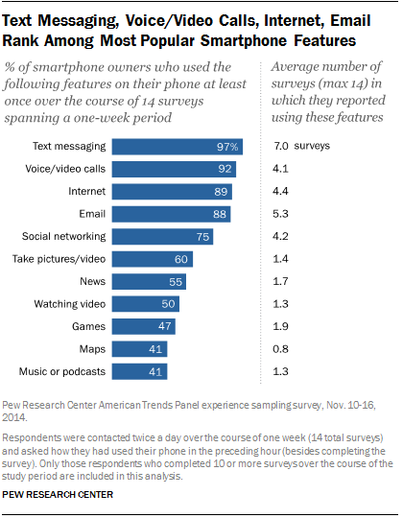

Fully 46% of smartphone owners say their smartphone is something “they couldn’t live without,”

Nearly one-quarter (23%) of smartphone owners have canceled or suspended their cell phone service because the cost was too expensive.